HCP CRM - Suggestion Call Dismissal Reason Update

Backlog
Description

Marketing would like to remove the following survey reasons from the Call Dismissal Survey.
- The recommended content is relevant to the HCP, but it’s not the right time to share it with the HCP
- HCP finds the content irrelevant or lacking value
Current Dismissal Survey reasons:
https://salesassist.lightning.force.com/lightning/r/Survey_vod__c/a1w3a000004xpoeAAA/view
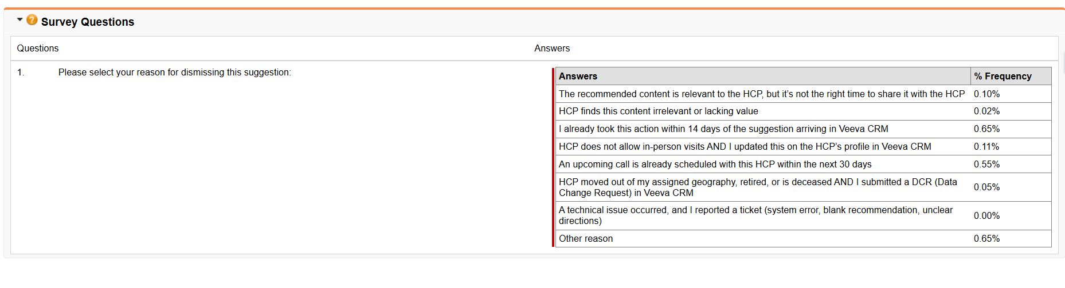
Profiles:
ADC - Sales
ADC - DSA Sales
ADC - Sales Manager

Acceptance Criteria

None

